Personal Emergency Evacuation Plans

(PEEPs)

Health and Safety Guidance for Schools

Issued by Occupational Safety Team
Last Revised: October 2017

Contents

Summary – What you need to do to implement these Procedures

- Introduction

- Responsibilities

- Designing A Personal Emergency Evacuation Plan

- Issues To Consider
  - Equipment
  - Identifying Assistance
  - Building Constraints
  - Training

5. Appendix A: Questionnaire

6. Appendix B: Personal Emergency Evacuation Plan

Summary – What You Need To Do To Implement These Procedures

What are your responsibilities as a school?
To ensure that you:-

- Talk to each disabled member of staff/pupil individually to discuss what assistance, if any, they may need to help them to evacuate the building safely in case of an emergency
- Complete a Personal Emergency Evacuation Plan (PEEP) in conjunction with the staff/pupil concerned
- Identify any adjustments necessary to existing emergency evacuation procedures and any additional equipment which may be required
- Provide training, where necessary for other staff who may be required to assist in the evacuation
- Monitor the effectiveness of these arrangements by means of practice evacuations and make adjustments if necessary
- Review each PEEP regularly and provide refresher training where required

What support will you receive from the local authority relevant department?
The department’s Staff will:-
- Help you with the interpretation of any aspect of the procedure
- Provide clarification and further detail on the application of the procedure
- Provide any further information on training that may be relevant

Introduction
Historically, the problems posed in evacuating a disabled person/pupil from a workplace/school have often been used as an excuse not to employ/admit them. The disabled person/pupil has been regarded as a “health and safety risk” rather than the building in question presenting the problem.
The principle that all areas of a building should be accessible to disabled employees/pupils has been enshrined in legislation from as far back as1970 but little headway appeared to be made until the Disability Discrimination Act came into force and Equal Opportunities Strategy was implemented. The Act and the strategy have now been replaced by the Equalities Act 2010 which came into force in 2011. Now, to comply with current Building Regulations, all new buildings must provide means of escape for disabled people.
Responsibility lies with school authorities to ensure that all employees/pupils, including disabled employees/pupils, can get out of the building quickly and safely in the event of an emergency. Procedures should already be in place in order to fulfil this duty, however, head teachers should consult individually with their disabled employees/pupils (parents/carers) and devise a personal evacuation plan for each individual that is tailored to the employee’s/pupil’s needs.

Head teachers Responsibilities
Head teacher should
- Talk to each disabled member of staff/pupil (parents/carer) individually to discuss what assistance, if any, they may require to help them to evacuate the building safely in case of an emergency
- Complete a Personal Emergency Evacuation Plan (PEEP) in conjunction with the employee/pupil (parents/carer) concerned
- Identify any adjustments necessary to existing emergency evacuation procedures and any additional equipment that may be required
- Designate and provide training, where necessary for other staff who may be required to assist in the evacuation
- Monitor the effectiveness of these arrangements by means of practice evacuations and make adjustments where necessary
- Review each PEEP regularly and provide refresher training where required

Designing a Personal Emergency Evacuation Plan (PEEP)
A PEEP is a document designed specifically for one person and normally only applies to one building. It is usually based on the existing evacuation procedures but takes into account the specialised needs of the particular individual for whom it is designed. Initial consultation with the disabled employee/pupil (parents/carer) should be carried out by means of a questionnaire in a sympathetic and considerate way. From the information gathered, a plan can be formulated which will ensure that the disabled person can be evacuated safely, with dignity and without putting anyone else at risk.
A PEEP should incorporate:
- Where in the building the disabled employee/pupil is based and/or is likely to visit
- Instructions on how to establish contact quickly in the event of an emergency e.g. existing alarm, pager etc.
- The type of assistance the disabled employee/pupil requires to be able to evacuate the building safely
- The way in which this should be provided, including details of those persons who are nominated to assist, and also of any equipment needed
- Details of the planned escape route(s) to follow
It may be necessary to provide the document in a variety of formats such as Braille, large print or audiotape.

Issues to consider
- Equipment
Most deaf staffs/pupil working with hearing colleagues will not need additional equipment to warn them of an emergency as they will see and understand the behaviour of colleagues when the alarm sounds. There may, however be need for a different type of warning device such as a flashing light in the washroom area or a vibrating pager to warn them that the alarm has sounded.
For those employees/pupils who have mobility problems or who are wheelchair bound it may be necessary to provide Evac Chairs to aid their evacuation. The number and location of these will depend on the building. Some arrangement for bringing the employee’s/pupil’s wheelchair downstairs, or having one available at the point of exit should also be considered when a disabled employee/pupil is transported in an Evac Chair, otherwise they may be stranded at the entrance to the building.
- Identifying Assistance for Disabled Employees/pupils
Where the PEEP indicates that a disabled employee/pupil will need assistance to evacuate a building, this should be sought from amongst their colleagues/staffs as there is no guarantee that the Fire and Rescue Service will arrive in time to evacuate disabled employees/pupils. It must be emphasised that assistants will not be in any greater danger than their colleagues/pupils. Whatever escape procedure is devised it must, by law, be safe.
Recruitment of assistants can be on a formal or informal basis i.e. included in the chosen person’s job description, or just by asking for volunteers. In either case cover for holidays and sickness must be taken into account. All assistants should be suitably trained in the techniques required to evacuate the disabled person. Where there is only a small staff team, it may be worth nominating and training all the staff, to ensure that there will always be someone on hand in case of emergency.
- Building Constraints
Stairways: Where escape routes and stairways are wide, it may be possible for persons with poor mobility or those who are wheelchair bound to descend at the same time as other staff, without putting either themselves or others at risk. However, where passages and stairs are narrow it is often prudent to wait for a short time in a safe area, e.g. a landing on a protected route, until the majority of people have passed, before making the descent.
These areas cannot, however, be considered as a “refuge” where a disabled person would wait for the Fire and Rescue Service to rescue them, as this arrangement no longer exists. It is therefore necessary for any disabled staff/pupil to have their own arrangements for a safe evacuation set out in a PEEP and all staff/pupil (parents/carer) concerned made aware of their responsibilities in an emergency situation.
If an Evacuation Chair is to be used and
- the evacuation chair can descend as fast as the general flow,
- the stairway is wide enough to allow other evacuees to pass,
- the evacuation chair can take a turn on a landing within its own width (no more than 600mm)
the disabled passenger will not have to wait until the main rush of people have left.

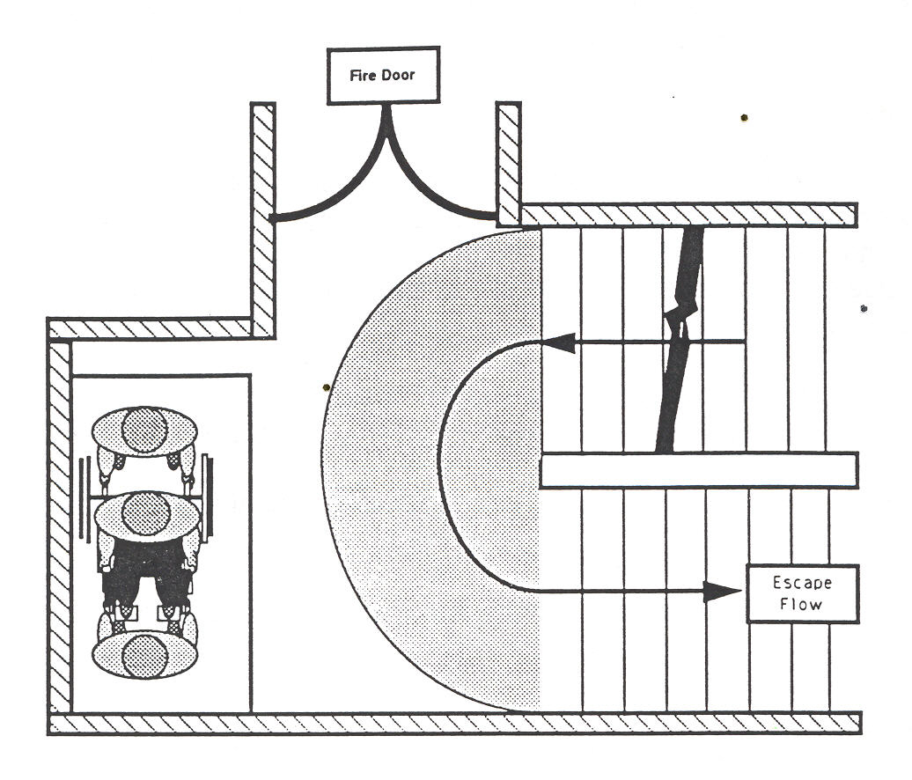

Lifts, would on the face of it, offer the easiest way of evacuating disabled people however, the majority are not suitable for this purpose and should not be regarded as a method of evacuation.
Any lift used for the evacuation of disabled people should either be a “Fire Fighting Lift” or an “Evacuation Lift”.
A Fire Safety Officer will be able to tell you if, and in what circumstances you can use your lift in the event of a fire.
- Training
The aim of training is to ensure that
  - persons nominated as assistants to a disabled person are aware of the organisation’s legal responsibilities for assisting disabled employees/pupils
  - they will be able to locate those disabled employees/pupils whom they are to assist within 1 minute of the fire alarm being sounded
  - they will be able to assist disabled employees/pupils, during an emergency, by using the methods identified in the employee’s/pupil’s PEEP
To achieve this, assistants may need training in guiding people with visual impairment or in particular moving and handling techniques. This will ensure that the disabled person can be safely guided, transferred to an Evacuation Chair or transported safely and with confidence in their own wheelchair out of the building.
Suppliers of Evacuation Chairs generally provide initial training in the use of this equipment and can also be called upon to provide refresher training when necessary. It is essential, however that these skills are practised together with the disabled person they are to assist as part of regular Fire Evacuation Drills.
Some disabled persons find difficulty in transferring from a wheelchair to an Evac Chair and do not feel comfortable using one, preferring to remain in their own wheelchair. In this case there are a number of ways in which a wheelchair and occupant can be transported downstairs.
Example 1 employs one assistant at the back, holding the handles of the wheelchair, controlling the rate of descent and another at the front walking backwards, guiding the chair.
Example 1 Example 2
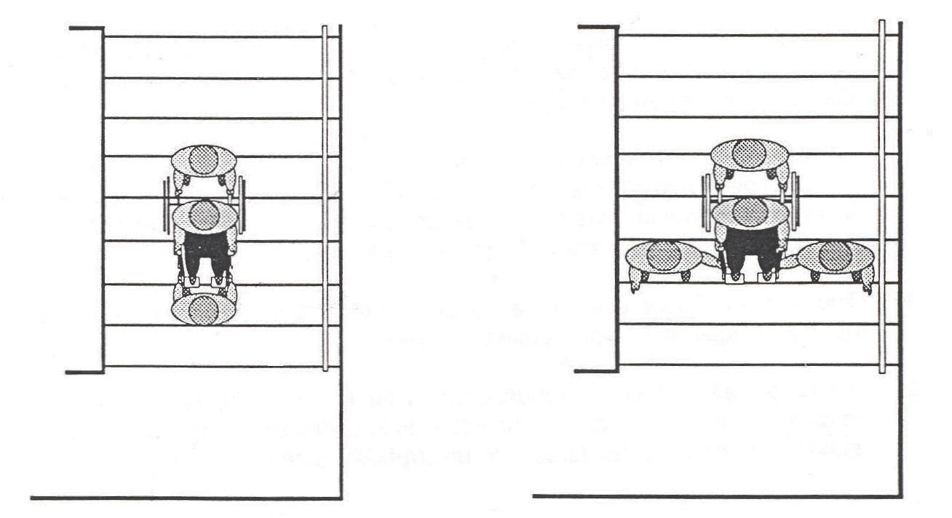

Example 2 employs one assistant at the back, holding the handles of the wheelchair controlling the rate of descent and one either side facing front holding the frame and guiding the chair.
In neither case is exceptional strength required, it is the technique employed which ensures that all the weight is transmitted through the chair to the stairs. Again these skills must be practiced in regular evacuation practices.

Further information and advice on producing Personal Emergency Evacuation Plans can be obtained from the relevant local authority department

Appendix A

EMERGENCY EVACUATION QUESTIONNAIRE

1. Why you should fill in the form

As your employer, has a legal responsibility to protect you from fire risks and ensure your health and safety at work. To do this properly we need to know if you need assistance during an emergency.

It shouldn’t take you more than a few minutes to complete the form.

2. What will happen when you have completed the form?

We will be able to provide you with any information you need about the emergency egress procedures for the building.

If you need assistance, we will be able to work out a Personal Emergency Evacuation Plan for you. To do this we will discuss the best ways of getting you out quickly and comfortably. We will involve you, and your parents/carer. But don’t worry we do not see you as the problem - you are not a safety risk. The problem belongs to us and the building in which you work.

NAME:
JOB TITLE/CLASS:
DEPARTMENT (staffs only):
BRIEF DESCRIPTION OF DUTIES (staffs only):

LOCATION (staffs only):________________________________

1. Where are you based for most of the time? Please name: the classroom, the floor and the room number if applicable

2. Will your job/learning take you to more than one location in the building which you are based?

YES |  |  |  | NO

3. Will your job/learning take you to different buildings?

YES |  |  |  | NO

AWARENESS OF EMERGENCY EVACUATION PROCEDURES

4. Are you aware of the emergency evacuation procedures which operate in the school building?

YES |  |  |  | NO

5. Do you require written emergency evacuation procedures?

YES |  |  |  | NO

5a. Do you require written emergency evacuation procedures to be supported by BSL interpretation?

YES |  |  |  | NO

5b. Do you require the emergency evacuation procedures to be in Braille?

YES |  |  |  | NO

5c. Do you require the emergency evacuation procedures to be on tape?

YES |  |  |  | NO

5d. Do you require the emergency evacuation procedures to be in large print?

YES |  |  |  | NO

6. Are the signs which mark the emergency exits and the routes to the exits clear enough?

YES |  |  |  | NO

EMERGENCY ALARM

7. Can you hear the fire alarm(s) provided in your place(s) of work/learning?

YES |  |  |  | NO |  |  |  | DON’T KNOW

8. Could you raise the alarm if you discovered a fire?

YES |  |  |  | NO |  |  |  | DON’T KNOW

ASSISTANCE

9. Do you need assistance to get out of your place of work/learning in an emergency?

YES |  |  |  | NO |  |  |  | DON’T KNOW

If NO, please go to question 13.

10. Is anyone designated to assist you get out in an emergency?

YES |  |  |  | NO |  |  |  | DON’T KNOW

If NO, please go to question 12. If YES, give the name(s) and location(s)

11. Is the arrangement with your assistant(s) formal (i.e. is the arrangement written into their job description?)

YES |  |  |  | NO |  |  |  | DON’T KNOW

11a. Are you always in easy contact with those designated to help you?

YES |  |  |  | NO |  |  |  | DON’T KNOW

12. In an emergency, could you contact the person(s) in charge of evacuating the building(s) in which you work and tell them where you were located?

YES |  |  |  | NO |  |  |  | DON’T KNOW

GETTING OUT

13. Can you move quickly in the event of an emergency?

YES |  |  |  | NO |  |  |  | DON’T KNOW

14. Do you find stairs difficult to use?

YES |  |  |  | NO |  |  |  | DON’T KNOW

15. Are you a wheelchair user?

YES |  |  |  | NO

Thank you for completing this questionnaire. The information you have given us will help us to meet any needs for information or assistance you may have. Remember we do not see you as the problem - you are not a safety risk. The problem belongs to us and the building in which you work,

Please return the completed form to:

APPENDIX B
PERSONAL EMERGENCY EVACUATION PLAN

NAME |  |  | LOCATION
 |  |  | Building
 |  |  | Floor
 |  |  | Room Number

Other areas of building visited on a regular basis __________________

Disability/incapability: _____________________________
_____________________________________________________

AWARENESS OF PROCEDURE

I have received the emergency evacuation procedures:

In Braille |  |  |  | On Tape |  |  |  | In BSL

In Print |  |  |  | In Large Print |  |  |  | In SSE

ALARM SYSTEM

I am informed of an emergency evacuation by:

Existing alarm system |  |  |  | Pager device

Visual alarm system |  |  |  | Other (please specify)

DESIGNATED ASSISTANCE: (The following people have been designated to give assistance when I need to get out of the building in an emergency).

METHODS OF ASSISTANCE: (e.g. Transfer procedures, methods of guidance etc.)
This will be the systems and procedures that have been discussed with all parties involved [the individual with special needs etc] and include things such as: -
1. Buddy system and name those individuals involved and details of the primary Buddies and whether they have received training in the use of the Evac Chair etc.
2. Also list what information, instruction or training all involved have been provided with.

EQUIPMENT PROVIDED:
The Evac Chair is generally going to be the only equipment to be provided. This is unless radio systems or other communication systems are provided.

EVACUATION PROCEDURE: (A step by step account beginning from the first alarm).
1. All staff to evacuate the building in an orderly manner, using the nearest route available and not stopping to collect belongings etc, unless provided with specific instruction to collect ‘prioritised’ items on route [these items would need to be items needed in the event of an emergency and would be left (retained) in a readily available, predetermined safe area].
2. Primary Buddies [or their secondary in the event of their absence] will locate their assignee and then assist them to the agreed predetermined exit route[s].
3. Both the Buddy and the individual who the PEEP is for, upon reaching the Safe Area [which is an escape route area that provides at least 30mins of fire protection] will contact the Chief Fire Warden/Marshal to notify them of their current location and provides names of the individuals who are there.

4. A decision will then be made as to whether a phased evacuation for this individual will take place, or a full evacuation needs to be carried out. [The phased evacuation is to allow the Chief Fire Warden/Marshal to determine whether or not there is an emergency or if this is a false alarm].
5. Once the decision has been made as to whether this is a Phased Evacuation, or Full Evacuation, then this MUST be relayed to the individual and their Buddy.
6. If Phased Evacuation, then the individual will remain in the Safe Area until the all clear is given and then they can return back to their work area.
7. If Full Evacuation is to take place, then the individual will need to state whether they are able to descend the stairs under their own physical capabilities. If not then an Evac Chair will be used.
8. Staff trained in the use of the Evac Chair will collect and evacuate the individual to the premise’s Fire Assembly Point, ensuring that the Chief Fire Warden/Marshal is made aware when they have vacated the premises.

SAFE ROUTE(S): (Please provide a diagram where necessary).
This will be the route[s] as agreed during the meeting.

NB - Copies of all the agreed procedures, including diagrams will be supplied to the pupil’s parents/carer, the individuals concerned and the Chief Fire Warden/Marshal, with a copy retained in the fire register.

Responsible person
Signature:

Print name: Date:

Beneficiary/Parent/carer
Signature:

Print name: Date:

